**Project Selection Page**

* Slow transition into Manage Accounts and individual project pages. To add a spinning wheel on browser tab when moving between pages. -- ??
* Mouse over more options menu symbol: tooltip “More Options” --- done

**Manage Accounts Page**

* Click on search icon for project list: search field enabled and ready to type – done only highlight click to type
* For mobile, “Administrator” to be changed to “Admin” to resolve word spacing issue -- harris
* When Org Admin demotes a Project Admin while the Project Admin is in the Manage Accounts page, the Project Admin still retains his admin rights and is able to save changes to role assignments successfully. This is a security issue. When the save button is clicked, the system should first query the rights of the user. If user has rights, save changes with message “Successfully updated”. Otherwise, user should see an error message “Unauthorized changes” then the page is refreshed. -- harris
* Project name displayed above “Search by username” search bar to improve understanding that user list is project specific--??
* If the user list is empty because there is only project admin and no other users, to display in Table “No other users have been assigned to this project.” -- done

**Create New Project Page**

* Shortcut to selecting option in drop down list by typing, first letter type is not responsive e.g. first press of F nothing happens, only on second press the list will jump to options starting with F. In addition, shortcut typing is too fast or not responsive. E.g. typing F, I, N for Finland is sometimes successful and sometimes not. If shortcut typing is successful, item should be displayed at the top of dropdown list. --- harris

**Home Page**

* Correction: To reinstate breadcrumbs after reviewing the UI outcome of removing breadcrumbs. Also, use » instead of |. -- done
* To add “Return to Project List” menu option at the top of burger menu on the left, to be differentiated from other menu options by using grey background and darker font colour -- done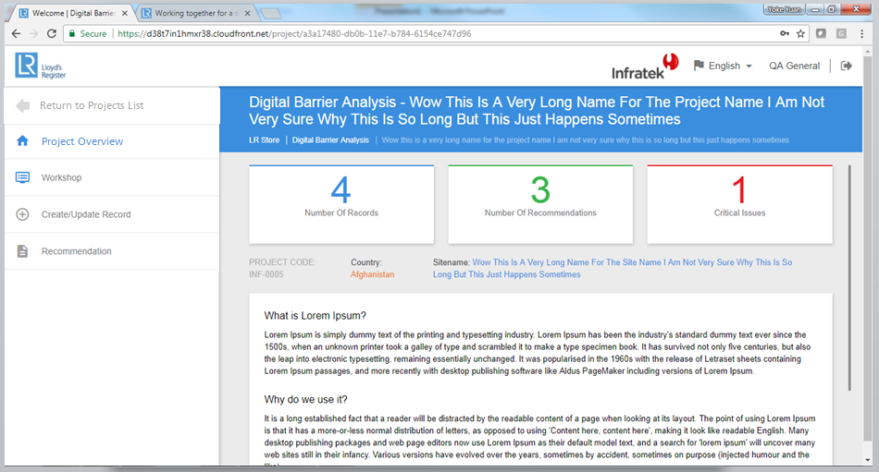
* “PROJECT CODE” to be changed to “Project No.” No full capitalization. -- done
* Browser scrollbar should not be enabled – sizing issue when project name requires 2 lines will increases thickness of blue area – done
* Mouse over settings symbol: tooltip “Settings” -- done
* In Norwegian and Swedish, language names to be Capitalized -- done

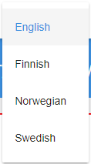 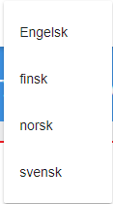 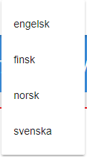

**Settings Page**

* “Pre-defined Lists” font size increase with no underline, same font size as “Risk Matrix” -- done
* “Pre-Defined List” to be changed to “Pre-defined Lists” -- done
* Work type, work operation, potential incident and consequence type to be flushed to the left -- done
* Add vertical axis title “Probability/Barrier” and horizontal axis title “Consequence” -- doing

**Workshop Page**

* Table is cut-off on mobile, can only see 2 columns and unable to horizontal scroll -- done
* “Upload Records” to be changed to “Select file” -- done
* “Risk Overview (Before Implementation of Suggestions)” to be changed to “Risk Overview (Existing Barriers)”, font size to be increased to be bigger than probability and consequence labels -- done
* “Risk Overview (After Implementation of Suggestions” to be changed to “Risk Overview (Existing Barriers + Recommendations)”, font size to be increased to be bigger than probability and consequence labels -- done
* Add vertical axis title “Probability/Barrier” and horizontal axis title “Consequence” -- doing
* Records table, font size decrease to same size as probability and consequence labels -- done
* Barriers and Recommendation headings should not be repeated, and alignment issue of the table needs to be fixed -- ??

**Create/Update Records Page**

* Scandinavian languages not implemented for Barrier Type and Dependency -- done
* What triggers the message for “Couldn’t create the record”? --- ??
* When there are no recommendations, input fields from New Risk Ranking are disabled since New Risk Ranking should be equal to Current Risk Ranking when there are no recommendations. To build in additional validation rule. -- harris
* When selecting records, only categories with records should be shown for work type, work operation and potential incident, so that user will not see categories without records and get confused with a long list -- harris
* When there are no existing records, UPDATE RECORD button to be disabled -- harris
* When RESET button is clicked, form returns to the top. UPDATE RECORD button not seen, and when user attempts to scroll, the form jumps back to the bottom again. -- harris
* “RESET” to be changed to “CLEAR” -- done
* When user clicks CREATE NEW/UPDATE button, form returns to the top. UPDATE RECORD button not seen, and when user attempts to scroll, the form jumps back to the bottom again. -- harris

**Safe Job Analysis Page**

* Remove PROJECT, Name and No. as they are repetitive and not required information for this page. Align Work Type and Work Operation to left. -- done
* Add “SAFE JOB ANALYSIS” button left of SAVE AS PDF button, disabled (indicative to user that this button is not clickable) and tooltip appears with “This feature has been marked for next phase development” -- done
* When Work Type and/or Work Operation is empty and user clicks on “SAVE AS PDF” button, highlight all empty mandatory fields red as prompt to the user. This should be standard UX.-- harris
* Work type and work operations drop down list available only for categories with existing records, so that user will not see categories without records and get confused with a long list -- harris
* When there are no existing records, drop down lists for work type and work operation will be empty -- harris
* Hide risk matrix until a selection of work type and work operation is made -- harris
* Add vertical axis title “Probability/Barrier” and horizontal axis title “Consequence” -- doing
* “Risk Overview (Before Implementation of Suggestions)” to be changed to “Risk Overview (Based on listed potential incidents)”, font size to be increased to be bigger than probability and consequence labels -- done
* “(S)” to be changed to “(s)” -- done
* Remove “Additional Recommendation(s)” -- done

**Recommendations Page**

* Add “CREATE ACTION PLAN” button above table aligned right, disabled (indicative to user that this button is not clickable) and tooltip appears with “This feature has been marked for next phase development” -- done
* Sorting option for S/No is missing -- done
* “open” to be changed to “Open” -- done
* “close” to be changed to “Closed” -- done
* Headers to be consistent: “Actions Assigned To” and “Status of Action” -- done

**General**

* All buttons to be in consistent colours --- done
* UX needs to be based on [Material Design Guidelines](https://material.io/guidelines/)
* For mobile, menu needs to be collapsible (refer to [Google material design](https://material.io/guidelines/patterns/navigation.html))
* For mobile, not responsive when phone orientation changes to landscape
* Risk matrix does not scale with size changes -> responsive design issue (tested on smaller laptop screen size, tablet and mobile)
* All drop down lists have to be ordered alphabetically

**IE Browser**

* Text are all over the place
* Many issues and generally not fit for testing